Problem Statement:

Design a program that will read a file of employee records containing employee number, employee name, hourly pay rate, regular hours worked and overtime hours worked. The company pays its employees weekly, according to the following rules: regular pay = regular hours worked × hourly rate of pay overtime pay = overtime hours worked × hourly rate of pay × 1.5 total pay = regular pay + overtime pay Your program is to read the input data on each employee’s record and compute and print the employee’s total pay on the weekly payroll report. All input data and calculated amounts are to appear on the report. A total payroll amount is to appear at the end of the report.

Flow Chart:

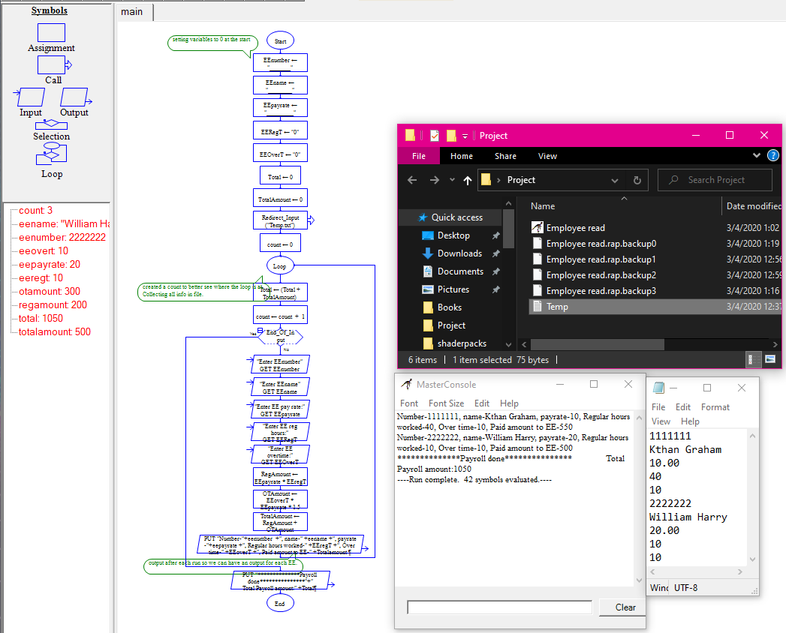

Algorithm:

Payroll

1 Read info from Temp

Number

Name

Payrate

Reg_hours

OT_Hours

2 reg_pay = payrate* Reg hours

3 OT_pay= OT_Hours*payrate*1.5

4 Totalamount= Reg_Pay+OT_pay

5 Total=Total+Totalamount

6End

Desk check

Pay rate: 10

Reg hours:10

OT hours:1

Totalamount:115

Payrate:20

Reg hours:10

OT hours:1

Total amount:230

Total:345